Model Exam
MLA0214 – Fundamentals of Machine Learning for Motlbot
Name: Siva Dakshitha Reg no:192425395

Experiment-2(LOGISTIC REGRESSION)
Aim
To classify spam emails using logistic regression and probability threshold.
Algorithm
- Encode data (Yes=1, No=0)
- Train logistic model
- Predict probability
- If probability > 0.5 → Spam
Code
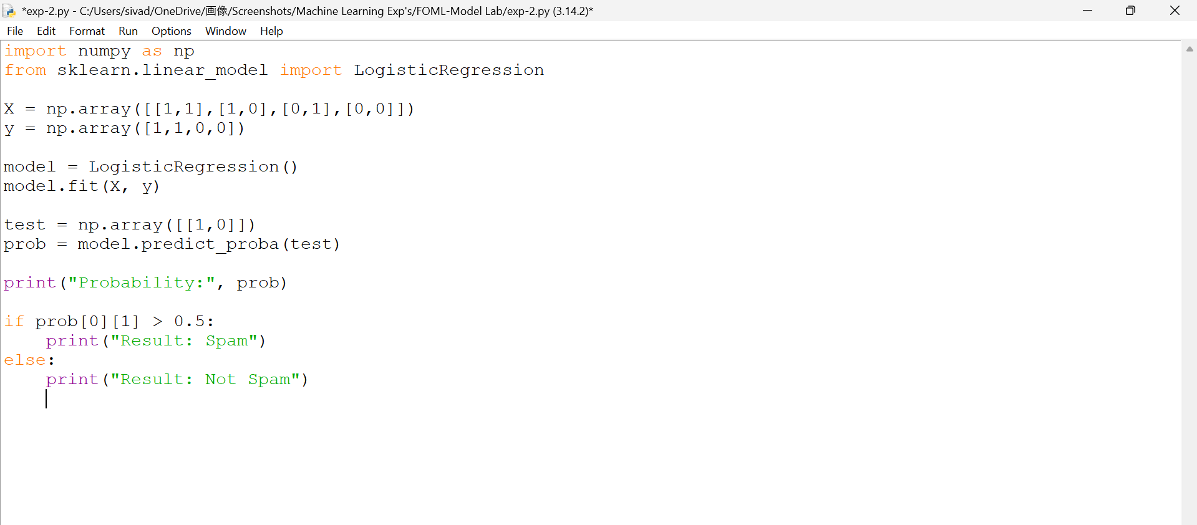

Output

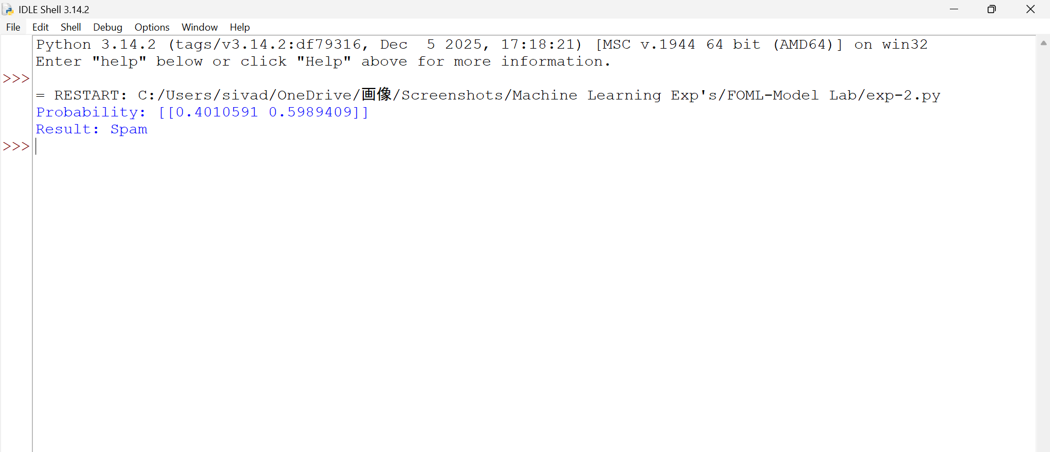

Result
Logistic Regression algorithm was successfully implemented and the spam email classification was performed successfully.

